**Sonic Pad**

**Firmware Burning Tutorial**

**（**MacOS**）**

|  |  |
| --- | --- |
| Version | V1.1 |
| Date | 2023/1/10 |
| version record | V1.0 initial version  V1.1 Chapter 4 Add Notes Before Burning |
| editor |  |

**Shenzhen Creality 3D Technology Co., Ltd**

**Catalog:**

1. Tools： 3

2. Enter the burning mode 3

3. Driver Installation 3

4. Sonic pad firmware burning 7

## Tools：

1. PhoenixSuit_MacOS.zip

2. (burn firmware) t800-sonic_lcd_uart0_1.0.6.40.112.img

3. Male to male USB cable

## 2. Enter the burning mode

1. When the Sonic pad is turned off, insert the USB cable into the CAM port
2. Press and hold the FEL button on the right with a paper clip
3. Press the Power button to power on the Sonic pad, then the Sonic pad will enter the burning mode

Power

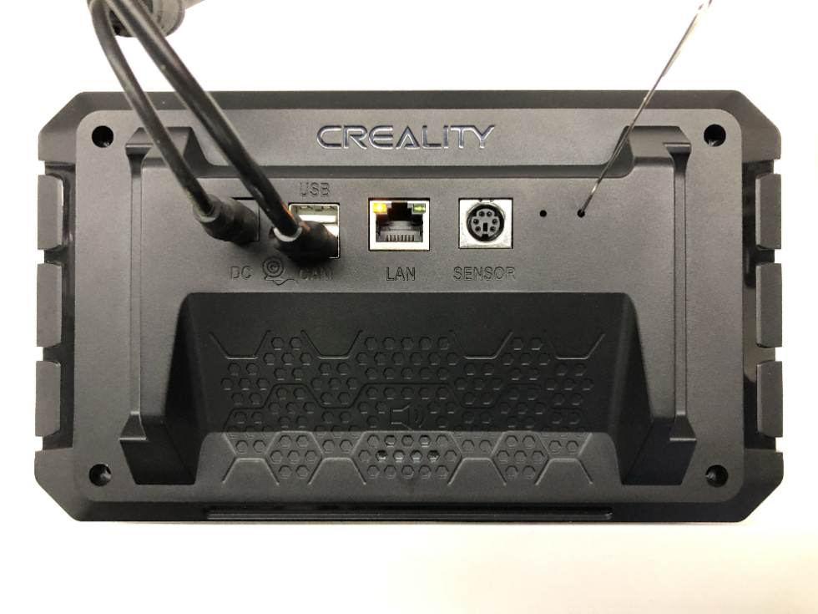

FEL

## 3. Sonic pad firmware burning

Notes before burning the firmware: Run the phoenixsuit software first, connect the Sonic pad to the computer with a male-to-male USB cable, and then let the Sonic pad enter the burning mode. The specific steps are as follows:

3.1 Open the terminal and enter the tool directory, execute ./phoenixsuit t800-sonic_lcd_uart0_1.0.6.40.112.img

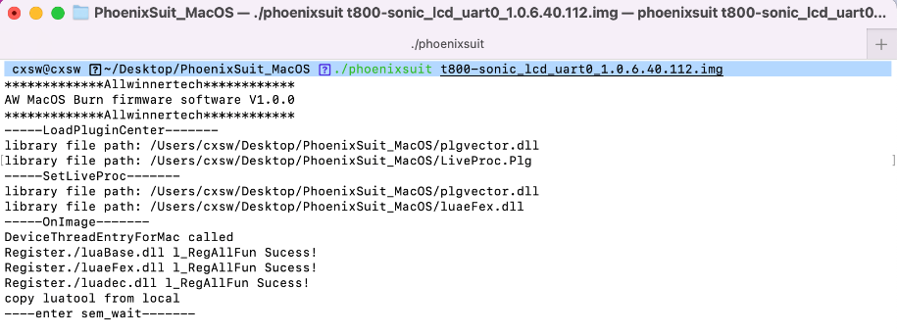

3.2 Sonic pad enters the burning mode, please refer to Chapter 2. The burning process is shown in the figure below:

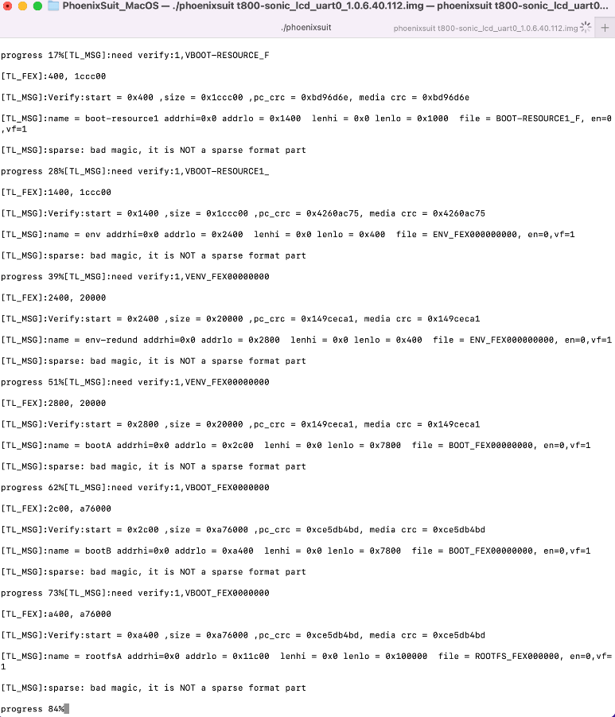

3.3 After the burning is completed, it will automatically restart after "progress 100% Burn Finish"

